http://www.sumanasinc.com/webcontent/animations/content/propertiesofwater/water.html
word bank: use each word only once.
covalently bonded electronegativity density entropy four Hydrogen bond
ionic negatively partial negative partial positive polar polar covalent
positively shared electrons solvent specific speed state

1 Life is based on water, primarily because if water’s _______________properties.
2 Water is formed by sharing of valence electrons between one O atom and two H atoms; because sharing valence electrons forms stable water molecules, water is termed a ______________________ __________________ compound.
3 Water is a polar molecule because its O atoms have higher e__________________________ than its H atoms, meaning that the O atom in each O—H bond of water attracts covalently bonded electrons strongly, whereas the H atoms attract the shared electrons much more weakly.
4 Drawing showing the polarity of a molecule of water:

5 What is represented by the two circles between each H and O? _____________________________
6 What is represented by the δ+ symbol by each H atom? _______________ _________________
7 What is represented by the δ- symbol by the O atom? _________________ _________________
8 The partially positive H atoms in one water molecule become attracted to the partially negative O atoms of adjacent water molecules, creating _______________________ ____________.
9. Draw a water molecule whose H atoms are attracted to the O atoms in two different adjacent water molecules. Show the Hydrogen bonds, weaker than the O—H covalent bonds, as dashed lines.

10 Water’s partially positive H and O atoms allow it to dissolve _________________ compounds like NaCl, as well as ________________________ covalent compounds.
11 Draw a _______________________-charged-metal ion surrounded by 3 water molecules, and draw a _________________________-charged nonmetal ion surrounded by 3 water molecules.

12 Solid water, ice, floats on liquid water because the molecules in the solid state are linked by more Hydrogen bonds between water molecules than are the molecules in liquid water. Each molecule of solid water is Hydrogen bonded to _______________ different water molecules, and these molecules spread farther apart than the molecules in liquid water.
13 Solid water has lower d_________________ than liquid water.
14 Water’s ability to form Hydrogen bonds also results in its having a high ________________ heat , a measure of how much energy 1g of substance absorbs to experience a 1⁰C increase in temperature.
15. The graphs show that the temperature of water remains constant as it is changing s_________________ from either solid to liquid OR liquid to gas. After the state of matter changes, then the temperature rises as energy is absorbed, so that the molecules vibrate with greater _________________.
16, Sketch and label a diagram showing how e__________________ (disorder related to how rapidly the molecules are vibrating) increases as the water increases in temperature and as it changes state first from solid to liquid, then liquid to gas. X-axis entropy, y axis Celcius Temperature.

http://www.sumanasinc.com/webcontent/animations/content/propertiesofwater/water.html
word bank: use each word only once.
covalently bonded electronegativity density entropy four Hydrogen bond
ionic negatively partial negative partial positive polar polar covalent
positively shared electrons solvent specific speed state

1 Life is based on water, primarily because if water’s solvent properties.
2 Water is formed by sharing of valence electrons between one O atom and two H atoms; because sharing valence electrons forms stable water molecules, water is termed a polar covalent (covalently bonded) compound.
3 Water is a polar molecule because its O atoms have higher electronegativity than its H atoms, meaning that the O atom in each O—H bond of water attracts covalently bonded electrons strongly, whereas the H atoms attract the shared electrons much more weakly.
4 Drawing showing the polarity of a molecule of water:
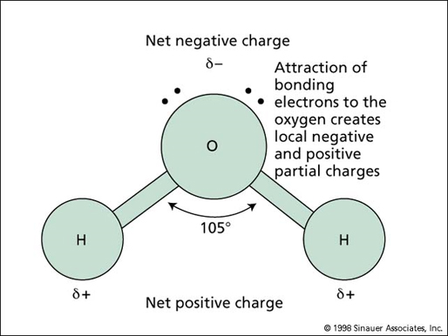http://startswithabang.com/wp-content/uploads/2008/08/waterstructure.jpg
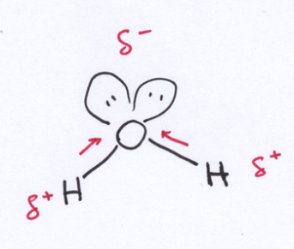http://scienceblogs.com/ethicsandscience/upload/2007/03/DipoleWater.jpg
5 What is represented by the two circles between each H and O? two shared electrons in the single covalent bond between H and O
6 What is represented by the δ+ symbol by each H atom? Partial positive charge on the less electronegative atom of H because on average, it is farther from the electrons than the oxygen atom.
7 What is represented by the δ- symbol by the O atom? Partial negative charge on the less electronegative atom of O because on average, it is Closer to the electrons than the less electronegative H atom.
8 The partially positive H atoms in one water molecule become attracted to the partially negative O atoms of adjacent water molecules, creating hydrogen bonds
9. Draw a water molecule whose H atoms are attracted to the O atoms in two different adjacent water molecules. Show the Hydrogen bonds, weaker than the O—H covalent bonds, as dashed lines.
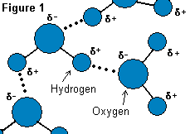http://homepages.ius.edu/GKIRCHNE/waterFig2.gif
10 Water’s partially positive H and O atoms allow it to dissolve ionic compounds like NaCl, as well as polar covalent compounds like alcohols or sugars or amino acids..
11 Draw a positively-charged-metal ion surrounded by 3 water molecules, and draw a negatively-charged nonmetal ion surrounded by 3 water molecules.

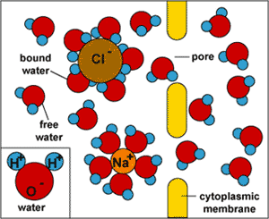 http://www.equistat.co.uk/images/membrane_pores.gif
12 Solid water, ice, floats on liquid water because the molecules in the solid state are linked by more Hydrogen bonds between water molecules than are the molecules in liquid water. Each molecule of solid water is Hydrogen bonded to four different water molecules, and these molecules spread farther apart than molecules in liquid water. 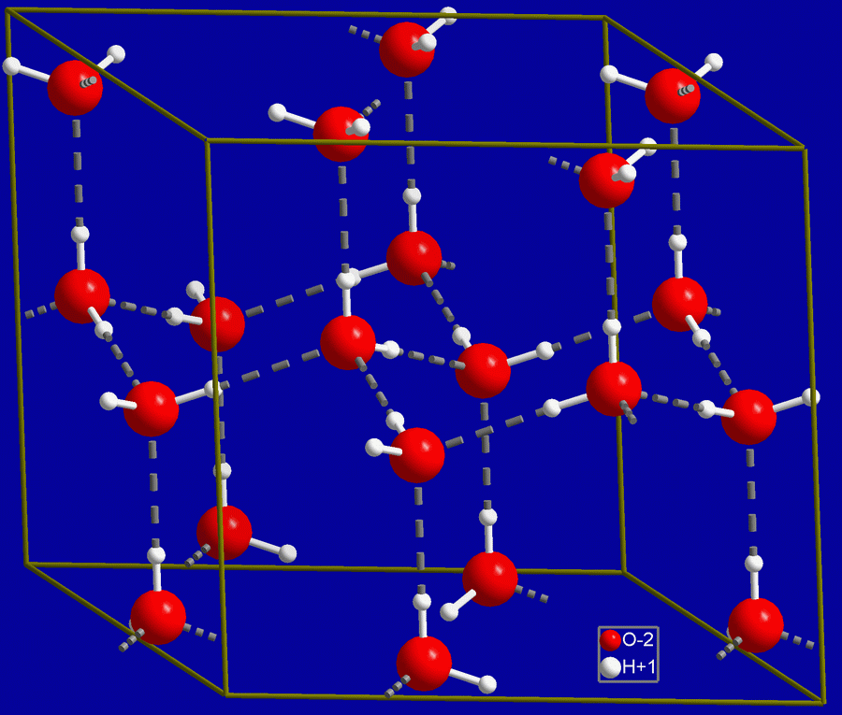 http://wpcontent.answers.com/wikipedia/en/5/5b/Hex_ice.GIF
13 Solid water has lower density than liquid water. Density liquid water: 1.00 g/ml, density ice: 0.92 g/1ml density=mass/volume
14 Water’s ability to form Hydrogen bonds also results in its having a high specific heat , measure of how much energy 1g of substance absorbs to experience a 1⁰C increase in temperature. Specific heat water= 1 calorie/(1g 1⁰C)
15. The graphs show that the temperature of water remains constant as it is changing state from either solid to liquid OR liquid to gas. After the state of matter changes, then the temperature rises as energy is absorbed, so that the molecules vibrate with greater speed (kinetic energy).
16, Sketch and label a diagram showing how entropy (disorder related to how rapidly the molecules are vibrating) increases as the water increases in temperature and as it changes state first from solid to liquid, then liquid to gas. X-axis entropy, y axis Celcius Temperature. Shows that the temperature doesn’t change as the water is changing state, from solid to liquid at the far left section with slope of 0 and from liquid to gas at right section with slope 0

